# DEVOPSDAY-1

**Installing and Setting Up WSL with Ubuntu on Windows 10 Step 1: Enable WSL**

Before installing Ubuntu, ensure that WSL is enabled on your Windows system. **Enable WSL Feature**

1. Open **PowerShell** as Administrator and run:
2. wsl --install

# Step 2: Install Ubuntu

1. Open **Command Prompt** or **PowerShell** and run:
2. wsl --install -d Ubuntu
3. wsl.exe -d Ubuntu

# Step 3: Set Up Ubuntu

When Ubuntu runs for the first time, it will ask you to create a new user account.

1. **Enter a username** (must start with a lowercase letter or underscore, and contain only lowercase letters, digits, underscores, and dashes).
2. **Set a password** (enter and confirm the password). If passwords do not match, you will need to retry.
3. Once successful, Ubuntu will be set up and ready to use.

**Install Jenkins on Ubuntu** # Update package lists sudo apt update -y

# Install Java (Required for Jenkins) sudo apt install -y openjdk-17-jdk

#verify java version java - version

**Add Jenkins GPG Key**

wget -q -O- https://pkg.jenkins.io/debian-stable/jenkins.io-2023.key | sudo tee

/usr/share/keyrings/jenkins- keyring.asc > /dev/null

**Add the Jenkins Repository**

echo "deb [signed-by=/usr/share/keyrings/jenkins-keyring.asc] https://pkg.jenkins.io/debian-stable binary/" | sudo tee /etc/apt/sources.list.d/jenkins.list

> /dev/null

# # Install Jenkins

sudo apt update -y

sudo apt install -y jenkins

**# Start and enable** Jenkins service sudo systemctl start jenkins

# Step 4: Add Jenkins Repository Key

**Step 4.1: Add Jenkins GPG Key**

wget -q -O- https://pkg.jenkins.io/debian-stable/jenkins.io-2023.key | sudo tee /usr/share/keyrings/jenkinskeyring.asc > /dev/null

# Step 4.2: Add Jenkins Repository

echo "deb [signed-by=/usr/share/keyrings/jenkins-keyring.asc] https://pkg.jenkins.io/debian stable binary/" |

sudo tee /etc/apt/sources.list.d/jenkins.list > /dev/null

# Step 5: Install Jenkins

sudo apt update -y

sudo apt install -y jenkins

# Step 6: Start and Enable Jenkins Service

sudo systemctl start jenkins sudo systemctl enable jenkins

# Step 7: Check Jenkins Status

sudo systemctl status jenkins

cat copy the localhost:8080 admin path display the password

=>By default, Jenkins runs as a system user (jenkins). If your script requires sudo, you must allow the Jenkins user to run commands without a password.

sudo visudo

Add the following line at the end:

jenkins ALL=(ALL) NOPASSWD: ALL

Save and exit.

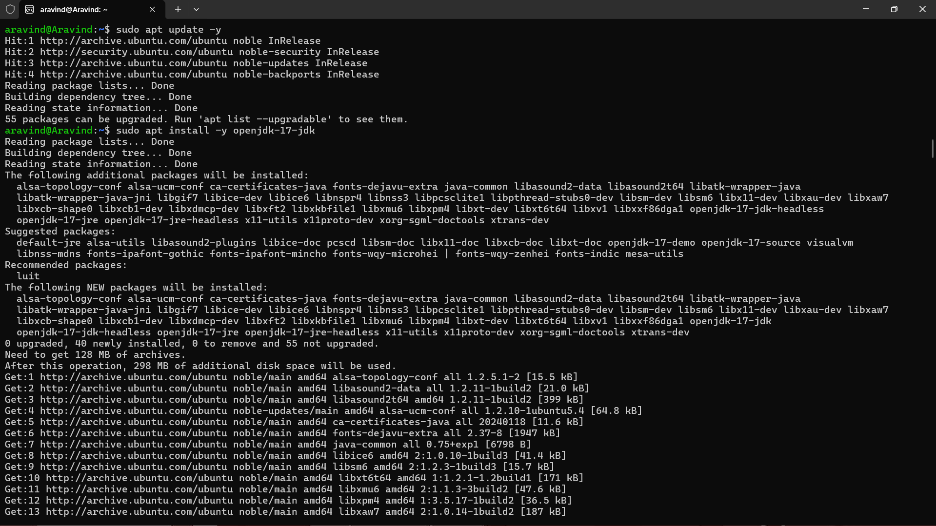

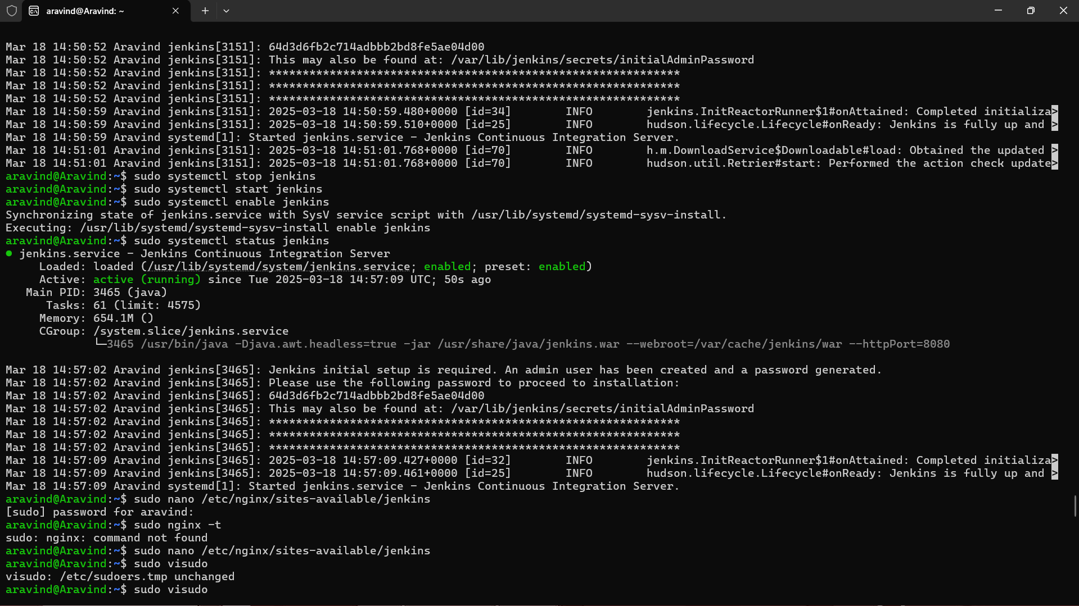

# 2. Access Jenkins Web Interface

Jenkins will be available at [http://localhost:8080](http://localhost:8080/)

# To Get the Jenkins Server URL, Follow These Steps:

**Method 1: Check the Default URL**

By default, Jenkins runs on port 8080. Open in a browser:

http://<your-server-ip>:8080

If you're on the same machine as Jenkins, use: [http://localhost:8080](http://localhost:8080/)

# Step-by-Step Guide to Creating a Freestyle Job in Jenkins to Install Nginx Step 1: Create a New Freestyle Job

1. Click on **New Item** from the Jenkins Dashboard.
2. Enter a name for the job, e.g., *Install-Nginx*.
3. Select **Freestyle project**.
4. Click **OK**.

# Step 2: Configure the Job Add Build Step

1. Scroll down to **Build** → Click *Add build step* → Select **Execute shell**. 2. Paste the following script in the command box:

echo "Updating package lists..." sudo apt update -y

echo "Installing Nginx..." sudo apt install -y nginx

echo "Starting Nginx service..." sudo systemctl start nginx

echo "Enabling Nginx to start on boot..." sudo systemctl enable nginx

echo "Nginx Installation Completed!"

# Step 3: Save and Run the Job

1. Click **Save**.
2. Click **Build Now**.
3. Check the **Console Output** to verify the installation.

# Step 4: Verify the Installation

1. **Check Nginx Status**

systemctl status nginx

If running, you should see output like *"active (running)"*.

# Open Nginx in Browser

[http://localhost:80](http://localhost:80/)

You should see the default Nginx welcome page

